How To Use Example VIs In “Special Calib” Folder

- Introduction
This document focuses on a special fixed calibration. The spectrometer consists of 5 pre-set fixed gratings that will be focused at specific, but different, vertical locations on the CCD. The calibration for each of the resulting strips is contained in an .ini file supplied by the manufacturer (Acton Research Corp.). Unique calibration values are grouped for each segment (in this case, 5 segments are present). These must be matched to the frame/image/data coming back from the camera. If the data needs to be reversed or flipped (rotated 180°) it is assumed that this is done before the calibration is applied.

Examples for Special Calibration from an INI file
  - The Special Calibration examples can be found in the folder “C:\Program Files\SIToolKit\LabVIEW\ExamplesXX_3_0_9_0\Special Calib”.
  - There are 4 examples to run: Ex5stripGlueNI.vi, Ex5strip5GraphNI.vi, ExFileReadNDisplayTifCalNI.vi, and ExFile5stripGlueNI.vi.

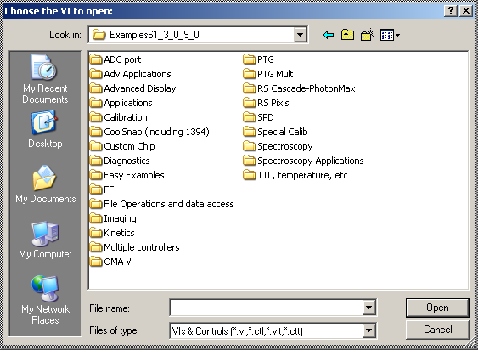

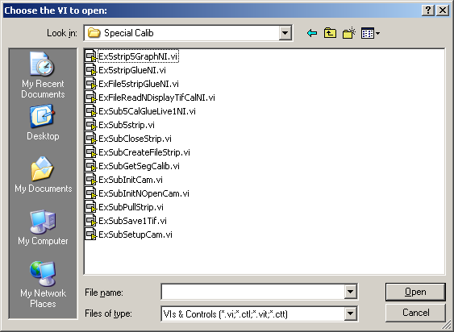

  - Glued strip: Ex5stripGlueNI.vi
    - Set an Exposure, Temperature, Offset, Intensifier Mode (usually will be shutter) Glue Resolution, Lower and Upper wavelengths (of the glued spectrum). The wavelengths are in nm. The ROIs can be changed if needed. The following screen shot shows the example set for collecting 5 strips with the strips binned together. An important value for the user to modify is Glue Resolution, a smaller resolution will be more accurate, but make the glued spectra’s x dimension larger.

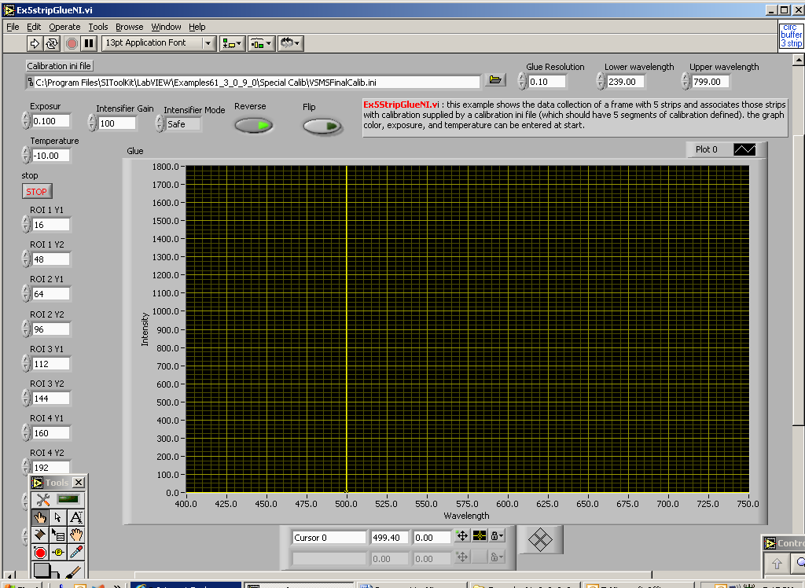

    - Run the program. A spectrum consisting of 5 glued spectra will be displayed. The spectra will be discernable as 5 distinct sections. If gaps exist between the sections, they will be filled with zeros.

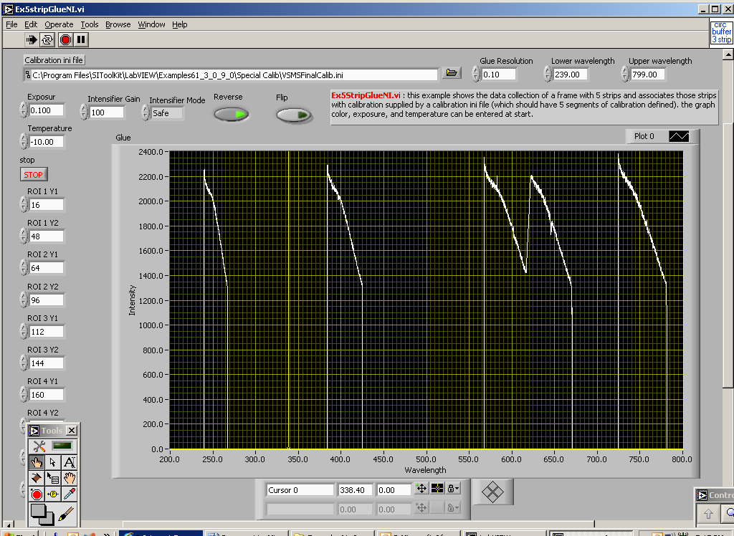

    - To stop the program, be sure to click the STOP button rather than the LabVIEW stop icon. This allows the program to clean up internal buffers.

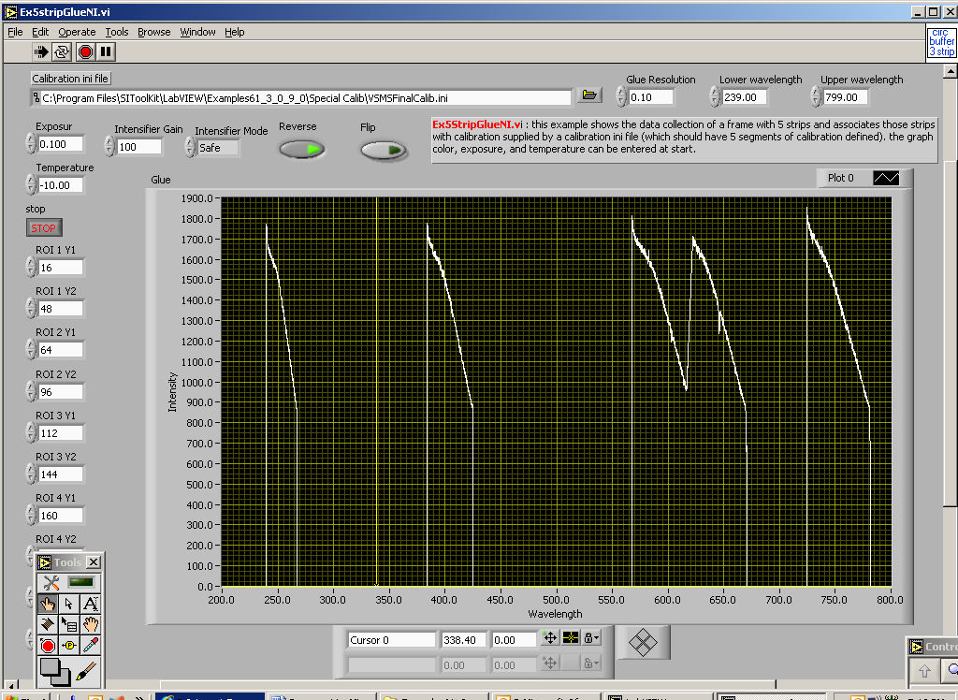

  - 5 strips in 5 windows: Ex5strip5GraphNI.vi
This example displayed each of a 5 strips in separate windows but does not glue the data. Each window will have a unique calibration based on values read from the manufacturer supplied calibration file. Again, use the STOP button to end the program to allow it to clean up.

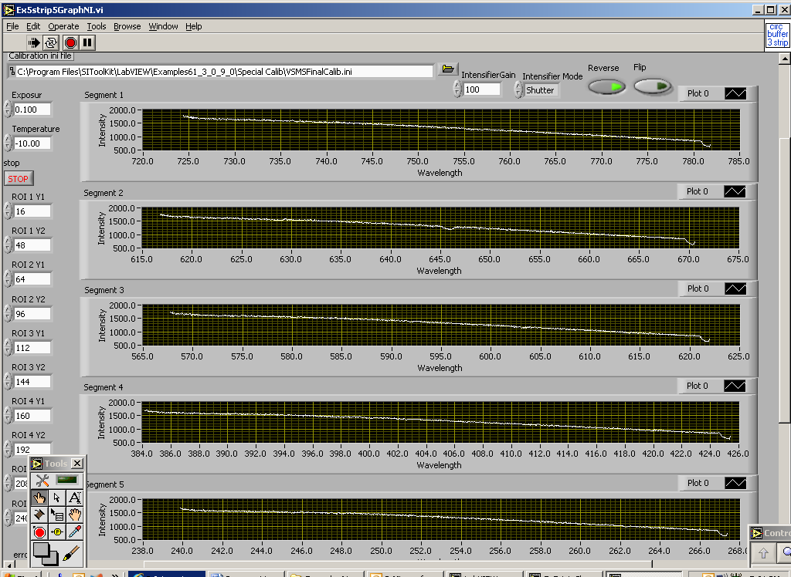

  - Reading a glued spectrum from file: ExFileReadNDisplayTifCalNI.vi
When you stop the Ex5stripGlueNI.vi example, the last glued spectrum is saved to a .TIF file with its calibration. This example shows how to read the spectrum and display it with its calibration. Again, use the STOP button to end the program and allow it to clean up.

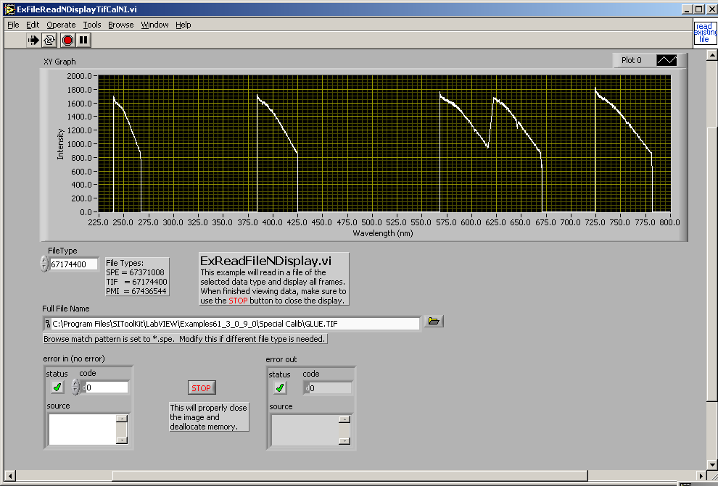

  - Reading an SPE file and gluing it. ExFile5stripGlueNI.vi.
In this example, the .INI and .SPE (generated by WinSpec or WinView) files must be selected before running. The SPE image/data should be 5 strips and match the INI file. The calibration from the INI file will be applied to the each strip after it is read. All 5 strips will then be glued and displayed as a calibrated spectrum.

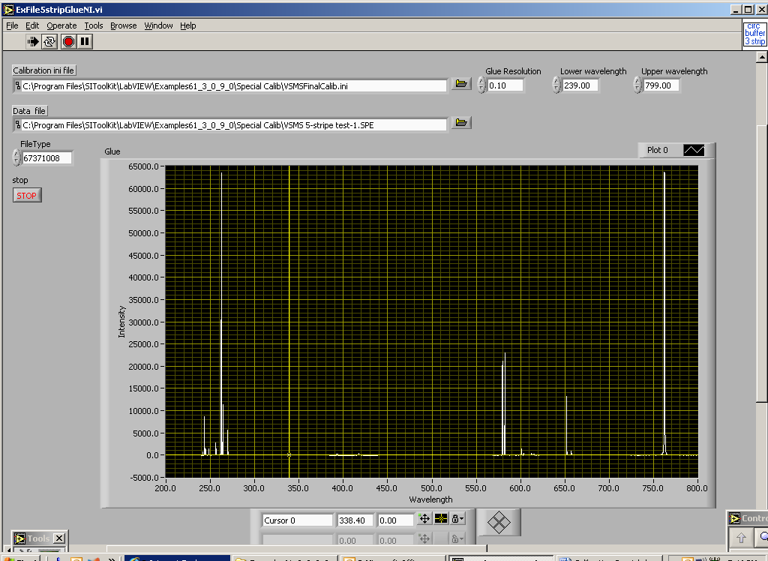

- LLBs and VI’s used for Special Calibration from an INI file and Glue VI’s.
  - The two palette files (located in the LabVIEW User.lib folder) associated with the calibration are SITKCalib.llb and SITKCalibAdvanced.llb. SITKCalib.llb contains the standard calibration vis including Open Calibration, Close Calibration, vis to put the calibration into a data handle and to extract a calibration array out of a calibration handle. SITKCalibAdvanced.llb contains the advanced calibration vis including those to read a calibration from a file and to perform the glue operation).

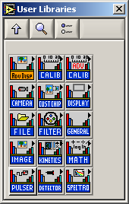

  - Standard calibration notes:
When opening a calibration object (handle) that will be used to hold calibration data read from an .INI file, use the CalibOpenNoHW vi as there is no software control of the fixed grating spectrometer. This palette also contains the vi to extract a calibration array from a calibration object (CalibGetCalibArray) and a vi to associate (put) a calibration with an image/data object (handle) (CalibPutXCalibToData).

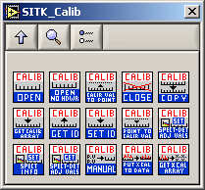

  - Advanced Calibration Notes:
This palette has the CalibLoadFromFile vi which loads a calibration from an INI file for the specified segment. It also has a set of glue vis CalibIncrementalGlueSetup, CalibIncrementalGlue CalibCleanUpGlue.

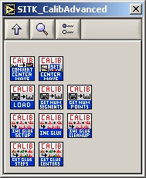

  - Below is an example of how to read the calibration ini file. This is the sub-vi ExSubGetSegCalib.vi which returns both a calibration array and a calibration handle (object).

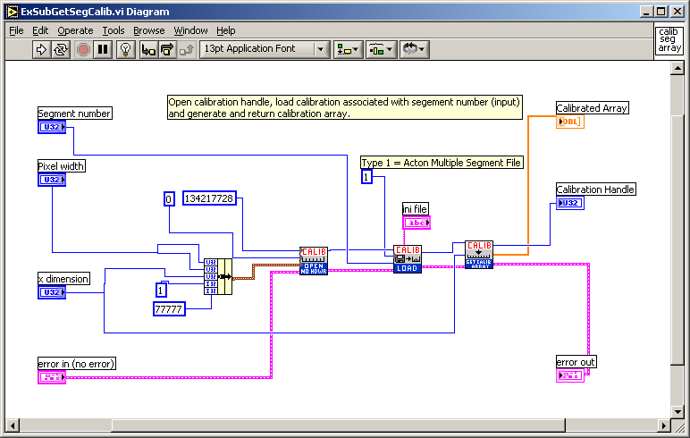

  - Below is an example of using the glue vis followed by an example of the standard LabVIEW style documentation provided with each palette vi.

